**Assignment 6.6**

**Problem Statement:**

Write a map reduce program to use Sequence file as input and save the output in key value output format.

Note: You can use the sequence file output which you have got in the earlier assignment of the same session.

**Program:**

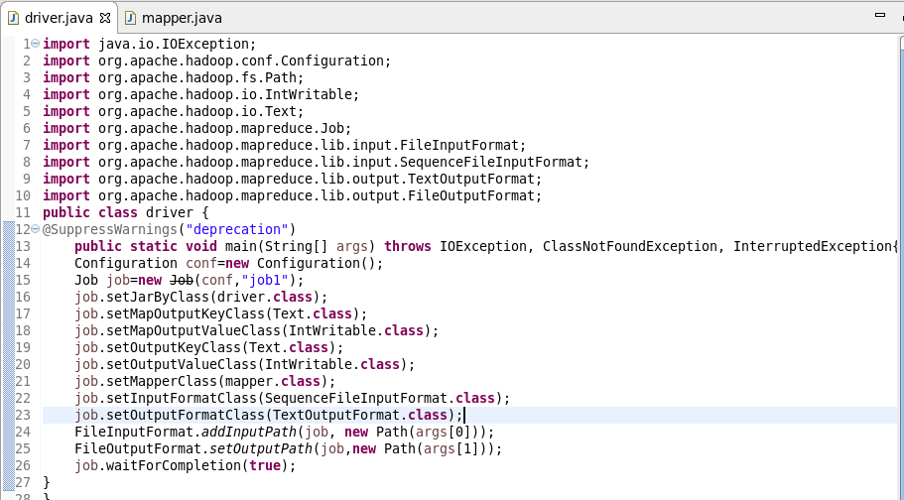

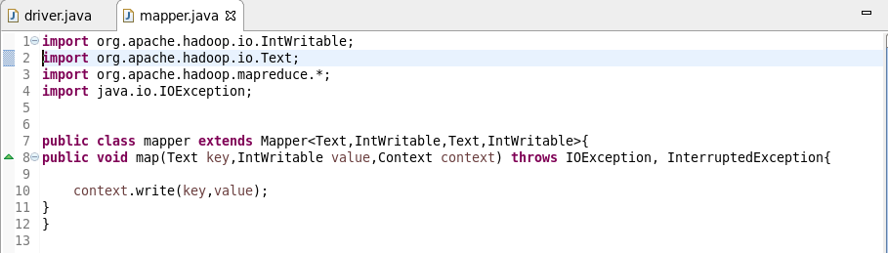

**Output:**

